Q.Write the code for unit converter.

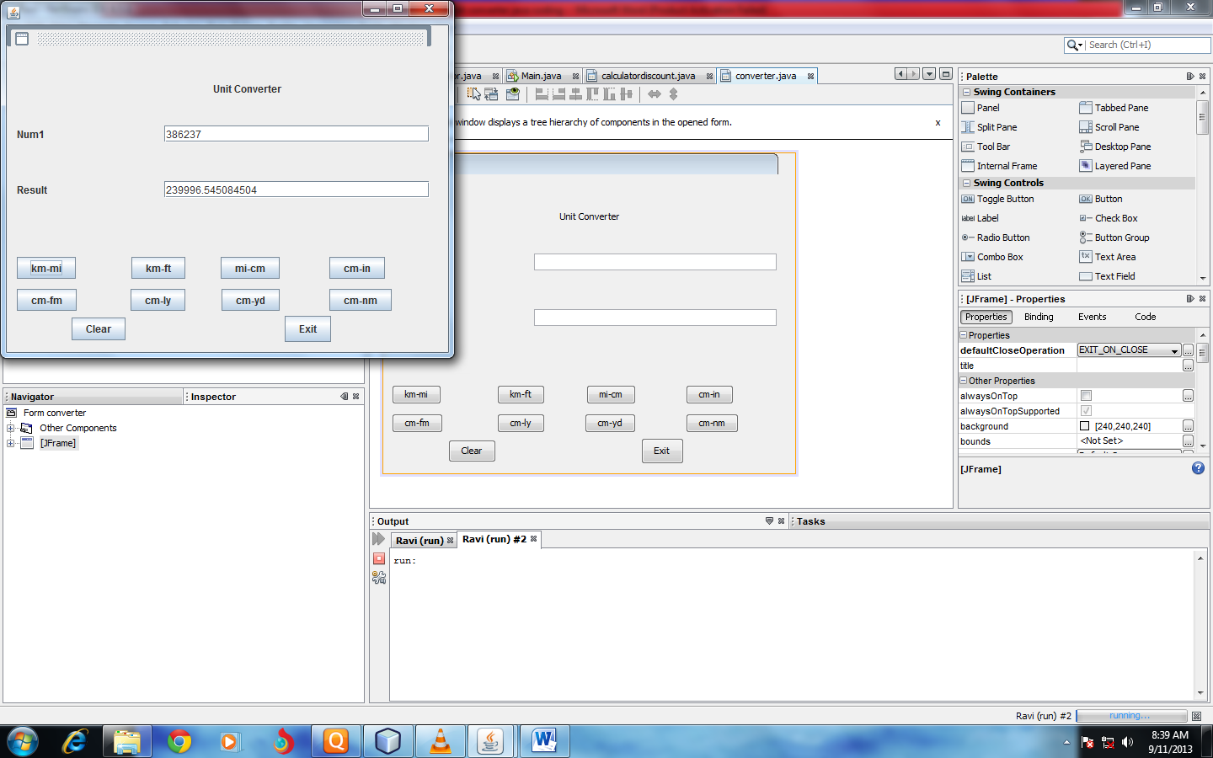

Coding---------------------

private void jButton1ActionPerformed(java.awt.event.ActionEventevt) {

int Num1=Integer.parseInt(jTextField5.getText());

Double Result=Num1\*0.621371192;

jTextField1.setText(""+Result);

}

private void jTextField2ActionPerformed(java.awt.event.ActionEventevt) {

// TODO add your handling code here:

}

private void jButton2ActionPerformed(java.awt.event.ActionEventevt) {

int Num1=Integer.parseInt(jTextField5.getText());

Double Result=Num1\*3280.839895;

jTextField1.setText(""+Result);

}

private void jButton4ActionPerformed(java.awt.event.ActionEventevt) {

int Num1;

Num1=Integer.parseInt(jTextField5.getText());

Double Result=Num1\*160934.4;

jTextField1.setText(""+Result);

}

private void jButton5ActionPerformed(java.awt.event.ActionEventevt) {

int Num1;

Num1=Integer.parseInt(jTextField5.getText());

Double Result=Num1\*0.393700787;

jTextField1.setText(""+Result);

}

private void jButton7ActionPerformed(java.awt.event.ActionEventevt) {

int Num1;

Num1=Integer.parseInt(jTextField5.getText());

Double Result=Num1\*0.005468066;

jTextField1.setText(""+Result); }

private void jButton8ActionPerformed(java.awt.event.ActionEventevt) {

int Num1;

Num1=Integer.parseInt(jTextField5.getText());

Double Result=Num1\*1.057023411E-18;

jTextField1.setText(""+Result); }

private void jButton3ActionPerformed(java.awt.event.ActionEventevt) {

int Num1;

Num1=Integer.parseInt(jTextField5.getText());

Double Result=Num1\*0.010936133;

jTextField1.setText(""+Result);

}

private void jButton6ActionPerformed(java.awt.event.ActionEventevt) {

int Num1;

Num1=Integer.parseInt(jTextField5.getText());

Double Result=Num1\*5.399568035E-6;

jTextField1.setText(""+Result);

}

private void jButton9ActionPerformed(java.awt.event.ActionEventevt) {

jTextField5.setText("");

jTextField1.setText(""); }

private void jButton10ActionPerformed(java.awt.event.ActionEventevt) {

System.exit(0); }